Polyvinylchloride
- Provide a drawing/image of the monomer, AND a drawing/image of the polymer chain.
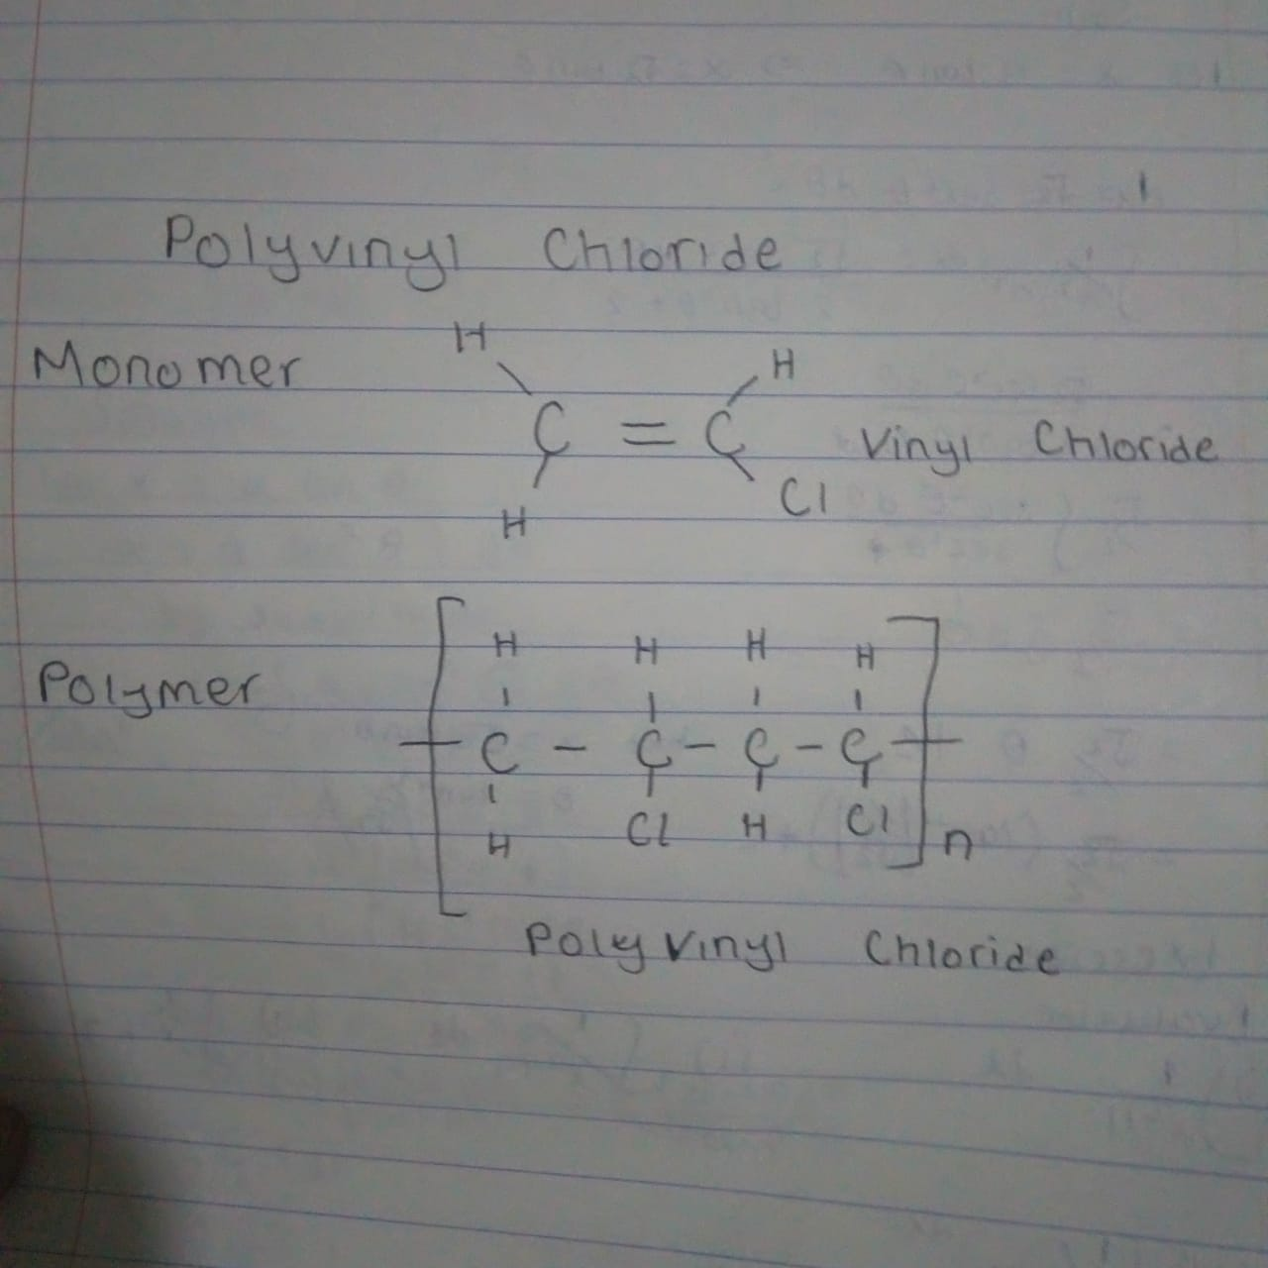
- Identify AND describe the organic chemical reaction that occurs to join the monomers to form the polymer in your own words.
The polymer above is polyvinyl chloride. This is a plastic that has the following chemical formula: CH2=CHCl. Polymers are formed through a process called polymerisation, where monomers react together to form a polymer chain. Two of the types of polymerisation reactions are addition polymerisation and condensation polymerisation. In our case polyvinyl chloride is formed by addition polymerisation
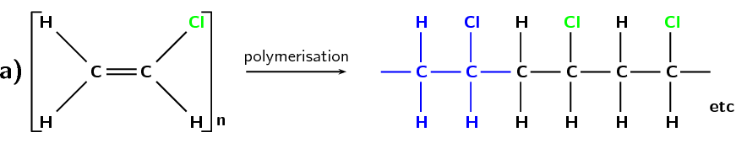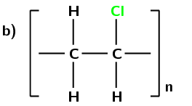
The electrolysis of salt water produces chlorine. The chlorine is then combined with ethylene that has been obtained from oil. The resulting element is ethylene dichloride, which is converted at very high temperatures to vinyl chloride monomer. These monomer molecules are polymerized forming polyvinyl chloride resin (Lewis, 1999).
- Identify at least three applications/uses in real life of the polymer.
Polyvinyl chloride is used as a rigid plastic, also as the insulation on electric wires and in tubing and blood bags (Patrick, 2005).

References
Lewis, R. (1999). Vinyl chloride and polyvinyl chloride. Occupational Medicine (Philadelphia, Pa.), 14(4), 719-742.
Natov, M. A., Vassileva, S. V., Kotchev, H. B., Djagarov, Z. S., & Popov, N. N. (1986). U.S. Patent No. 4,594,372. Washington, DC: U.S. Patent and Trademark Office.
Patrick, S. (2005). Practical guide to polyvinyl chloride. I Smithers Rapra Publishing.

